ECE 323L Basic Electronic Circuits Laboratory

Lab 2

Name:

Do the following exercises. Report your results by editing this Word document and submitting it in WebCT.

Materials: motor, micro lamp, bi-pin lamp, LED, 1000-2000 ohm resistor, 120-200 ohm resistor, light-sensitive resistor.

- Connect a 1000-2000 ohm resistor to the HP 3630A power supply and HP 34401 multimeter as follows:

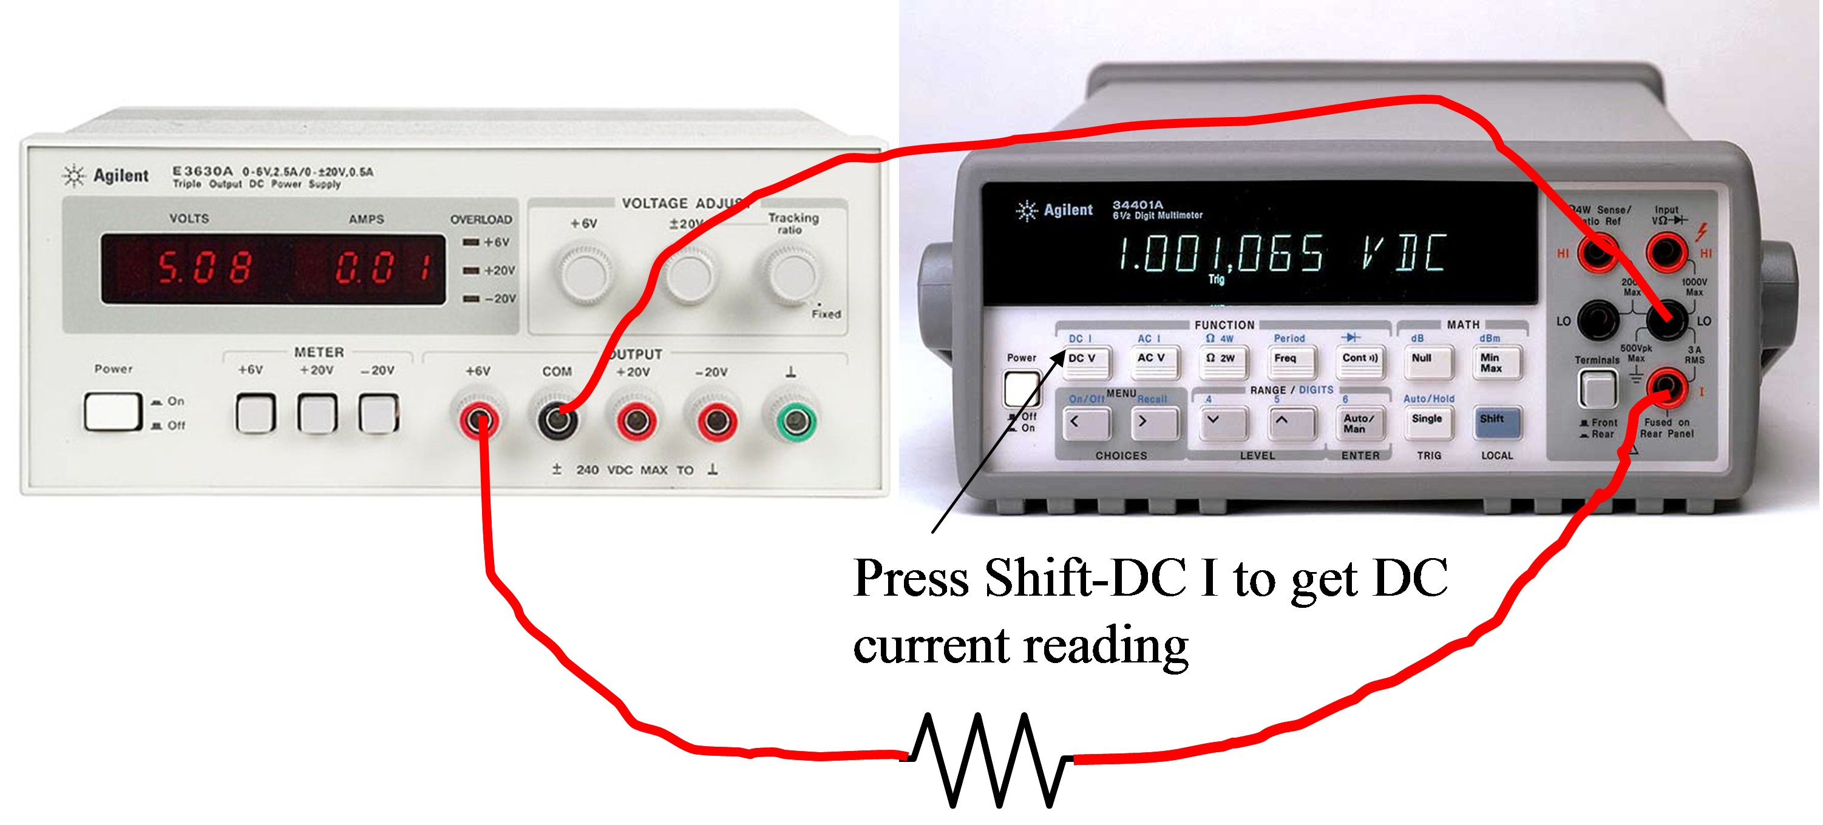

Record the voltage and current for at least five evenly-spaced, input voltage levels from 1 to 6 volts. The voltages do not have to be exact round numbers. Record the values on a spreadsheet and plot current vs. voltage. Ohm’s law says that the data should lie on a straight line whose slope is the conductance (1/R). Find the resistance from your data and compare the value to that obtained by using the DMM:

Nominal Value | Measured Value | Calculated from slope

Paste a copy of your Excel plot here. A plot of the difference between the fitted line and the data points is often informative and you should include that plot as well if you take the time to do additional analysis.

- Connect the motor in place of the resistor in the above figure. Vary the voltage from 1 to 6 volts, measure the current for the unloaded motor and the stalled motor. To stall the motor, grab the shift tightly with your fingers so that it can not rotate. Do not stall the motor for longer than needed to measure the current. Fasten a small piece of paper on the motor to observe the speed of the motor as a function of the voltage.

Voltage | Currrent | Stall current

- Measure the resistance of your photocell under the following conditions:

Conditions | Resistance
Dark
Room lighting
100 W lightbulb

- Measure the voltage across your 9-v (nominal) battery.

Voltage

- Do the following for the light sources in your toolkit:

Connect the battery and your DMM to measure current.
The red LED must be connected with the longer lead toward the positive side of the battery. There is also a flat area on the rim of the LED marking the negative end of the LED. Insert a 100-200 ohm resistor as shown in the circuit diagram at the bottom of the page. Power is the product of voltage and current. Measure and use the voltage drop across the LED in determining the power of the LED.

Source | Measured Current | Calculated Power
Micro lamp
bi-pin lamp
LED

- Measure the resistance of your photocell when placed next to each of the light sources above and covered with a dark cloth so that the photocell receives light only from the light source under test.

Conditions | Resistance
Micro lamp
bi-pin lamp
LED

- Layout the following circuit in Multisim. When you start simulation (using the toggle button), the switch should open and close in response to the space key and the LED arrows should change color.

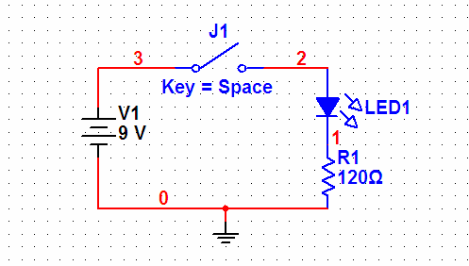

maintained by John Loomis, updated 14 January 2008

